

[Document title]

[Document subtitle]

Abstract

[Draw your reader in with an engaging abstract. It is typically a short summary of the document.   
When you’re ready to add your content, just click here and start typing.]

First Last

[Email address]

First Last

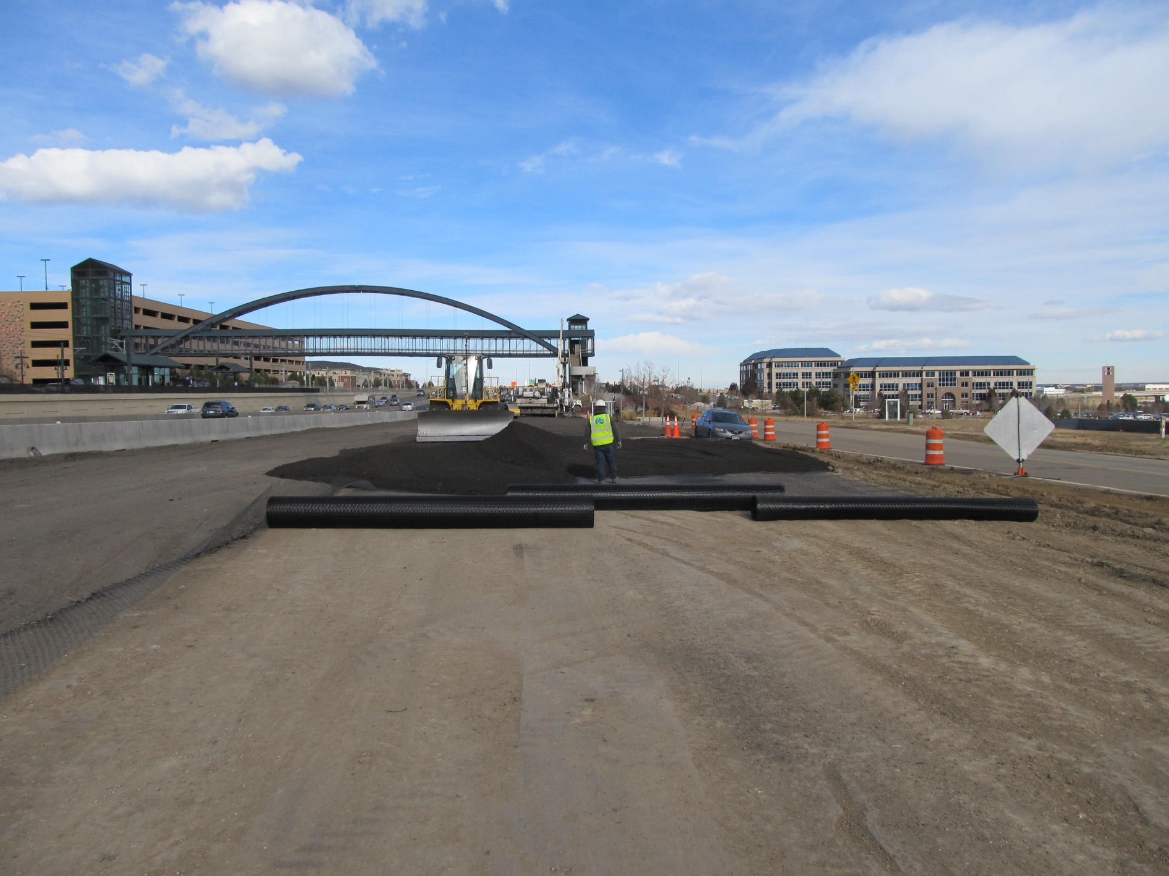



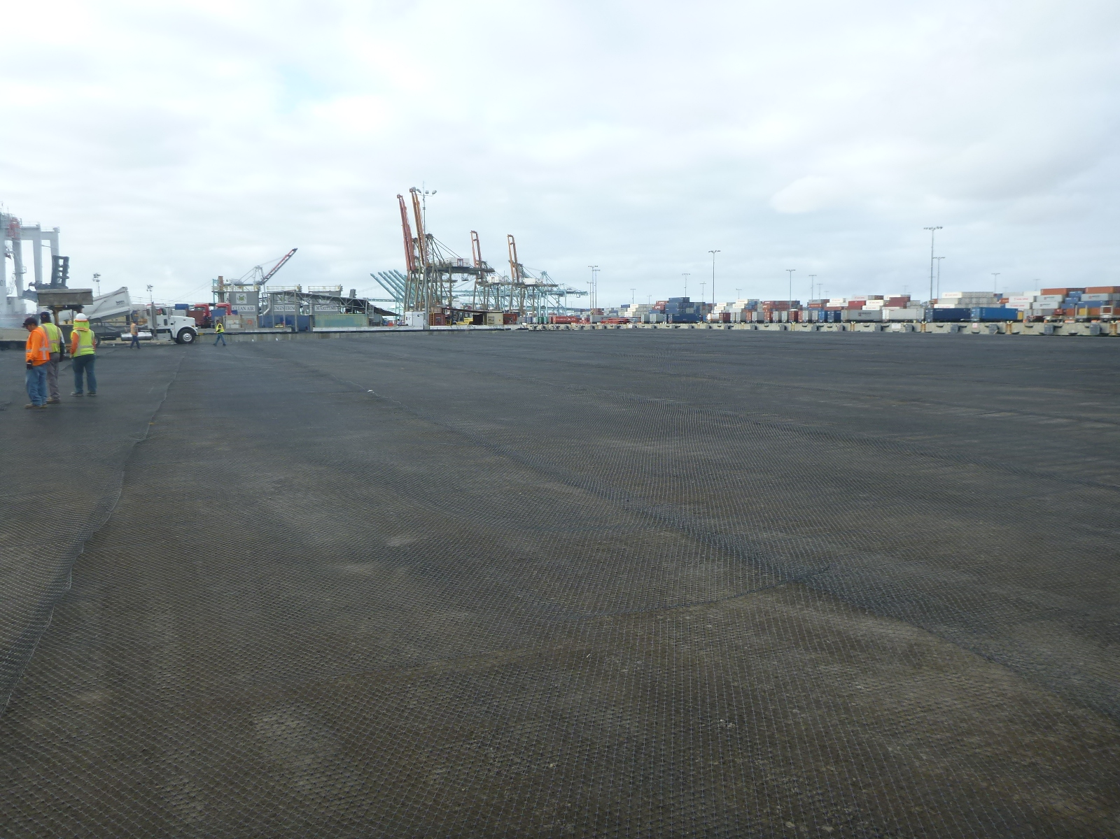

Section Title



Section Title

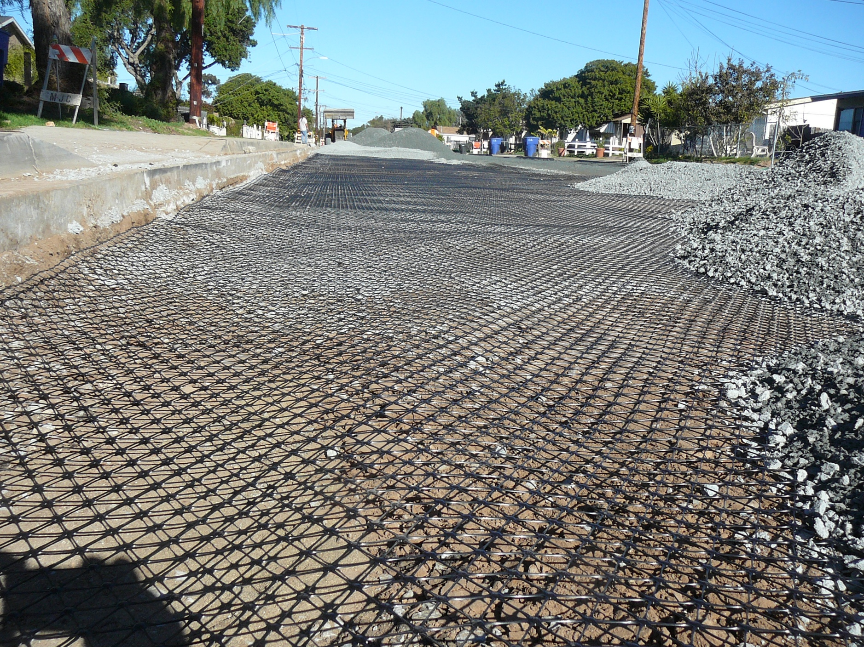



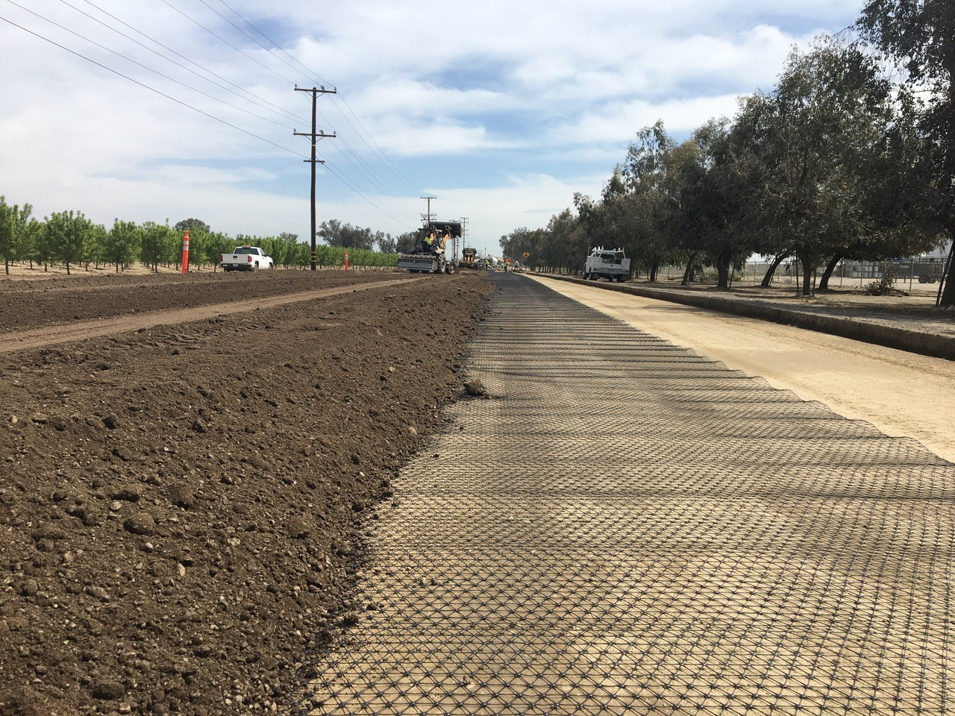

Section Title

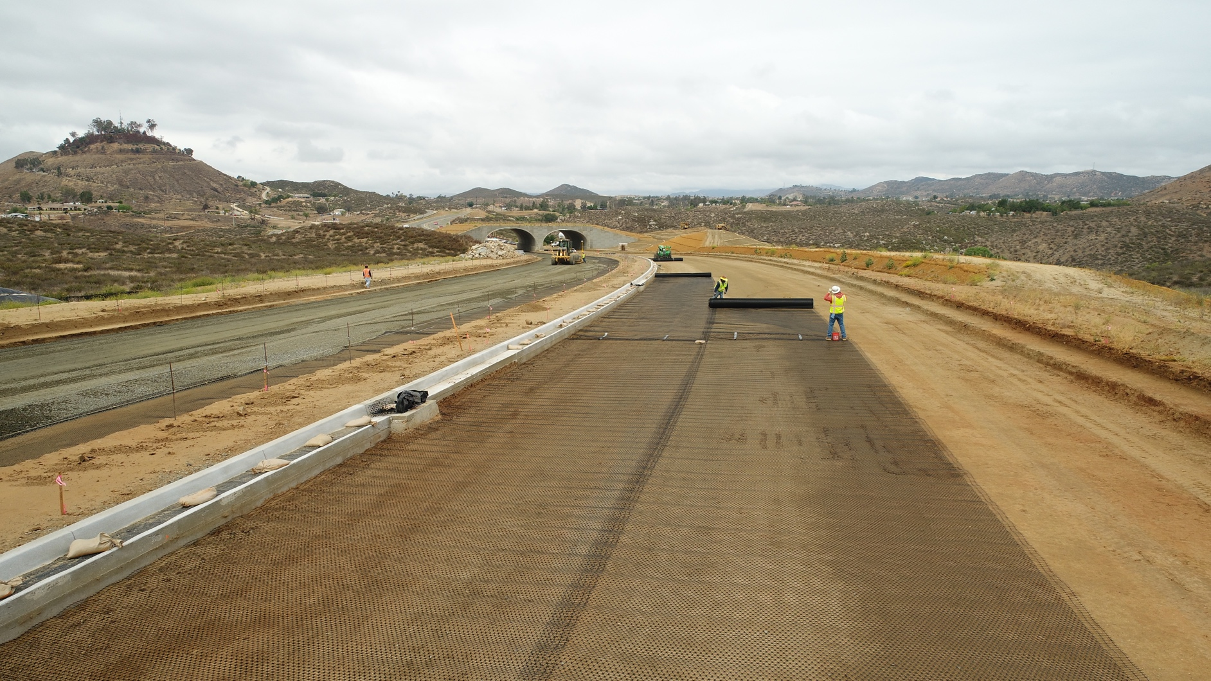

Section Title



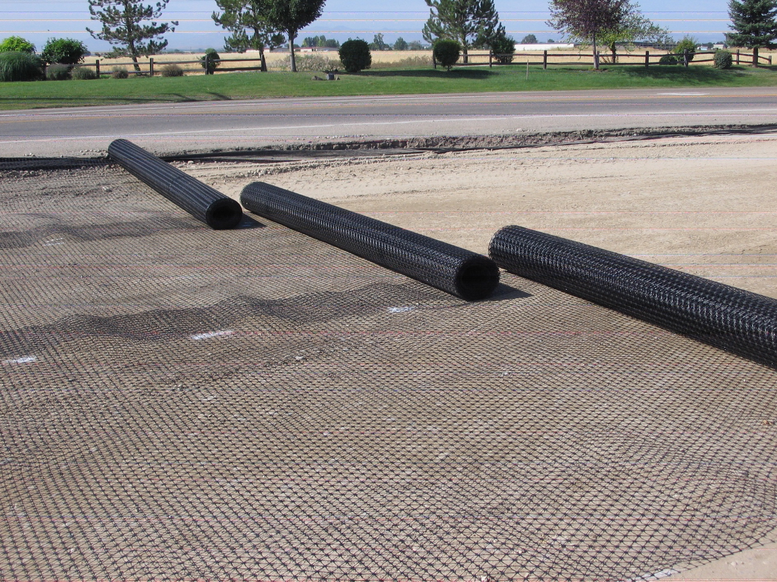

Section Title



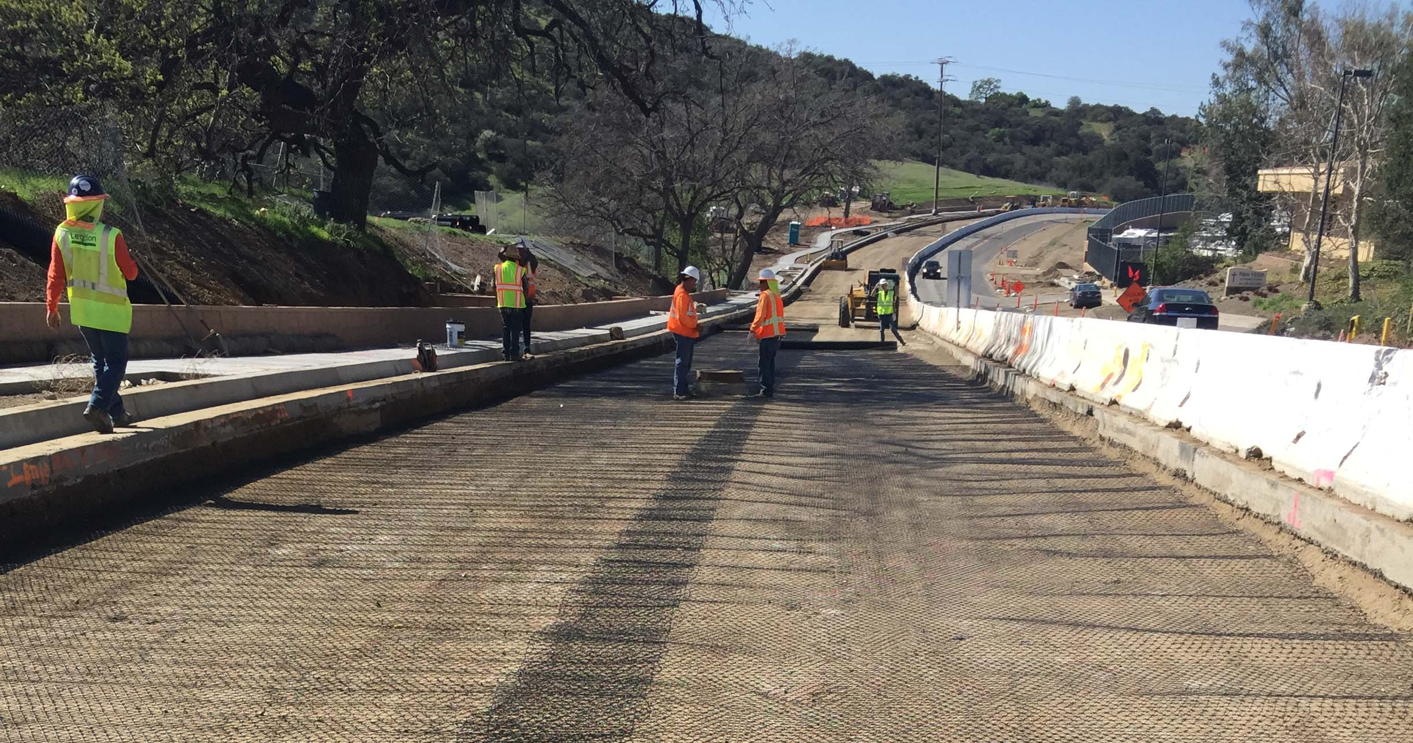

Section Title